Free code camp – Home page

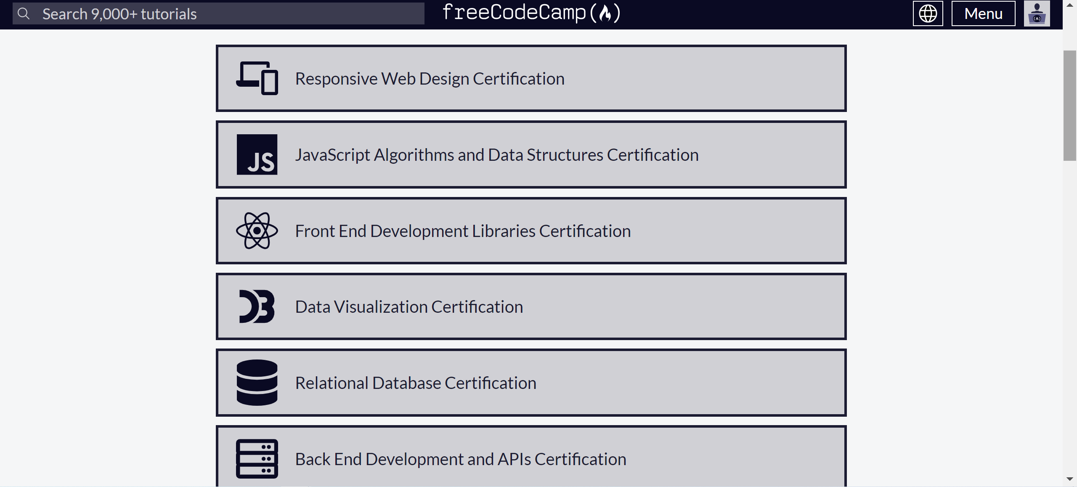

1. Single column layout
2. Elements & Tags -

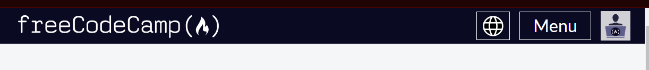

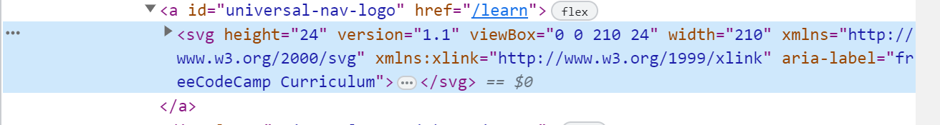

Header and Navbar – SVG, Input, path, button, Rect, Ellipse

3.Heading and Paragraphs.

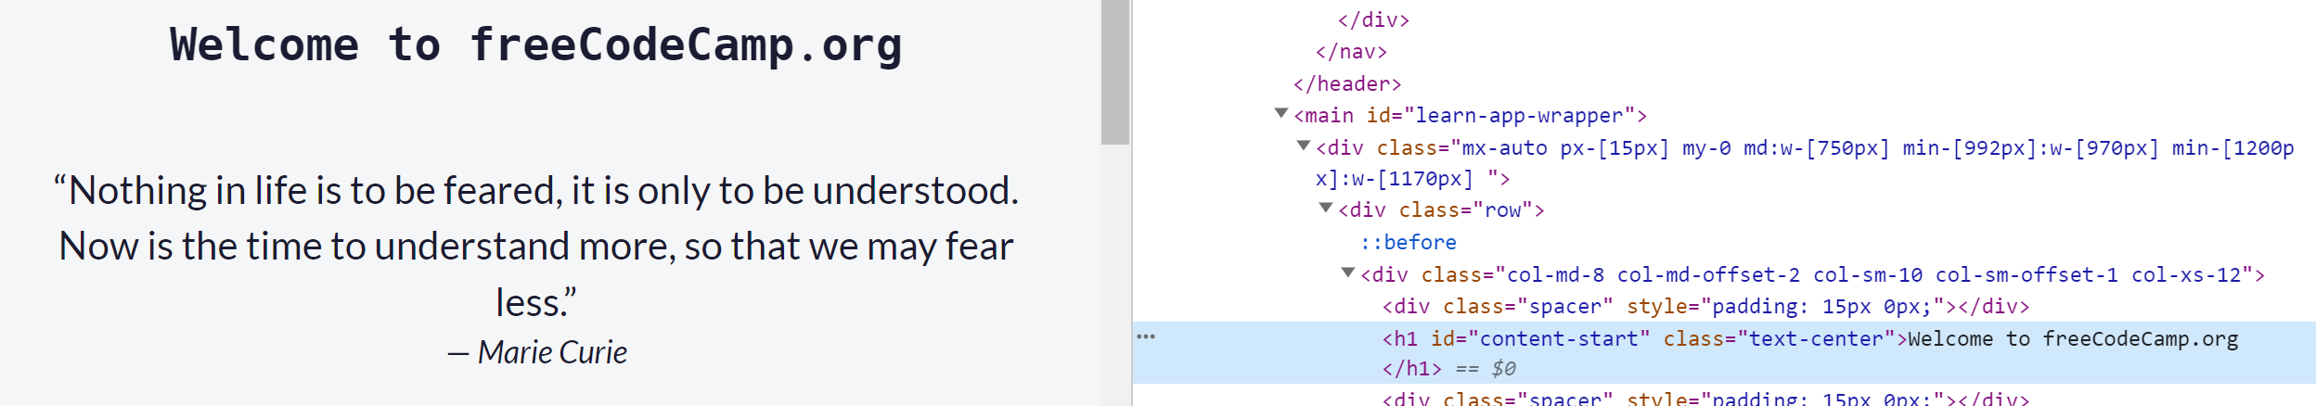

H1,Q, footer, blockquote,

4.Semantic elements – main, nav,

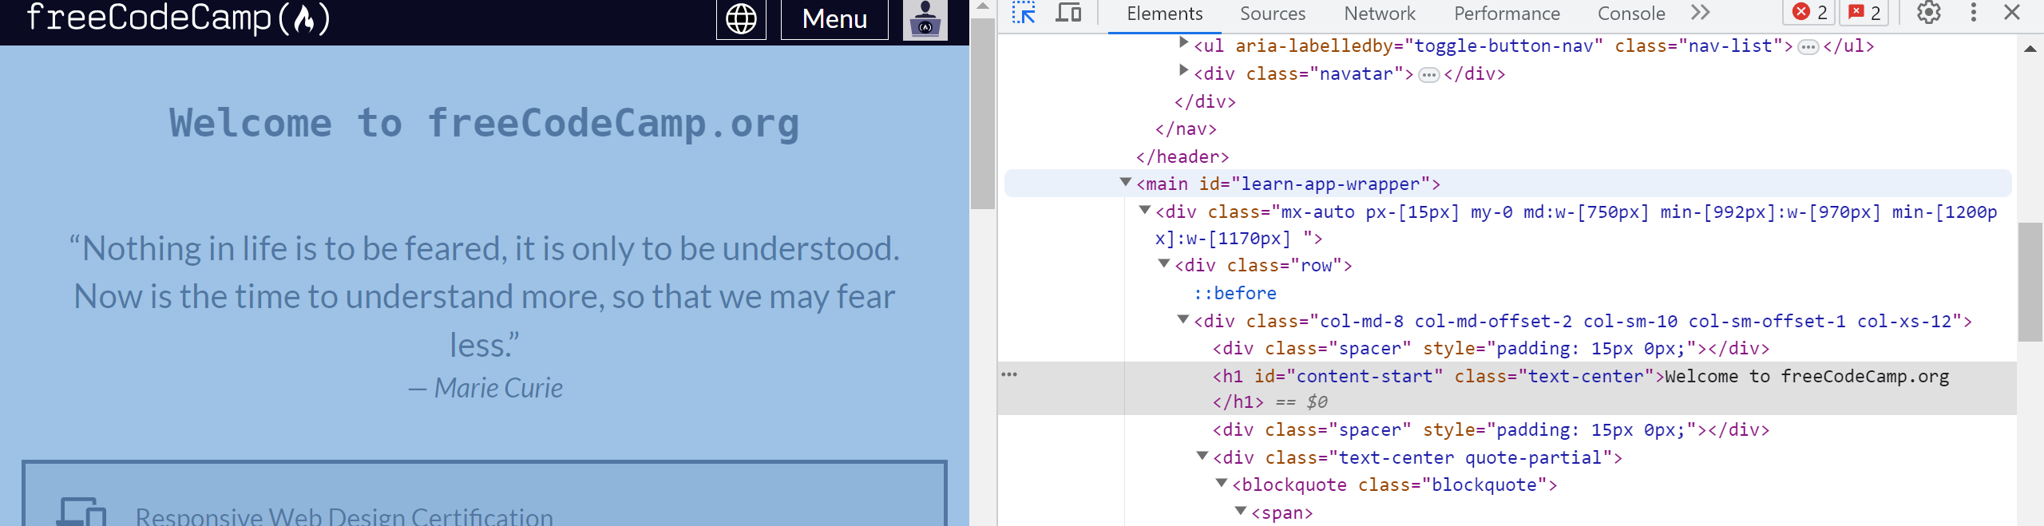

5. list – used to displaying topics in list form.

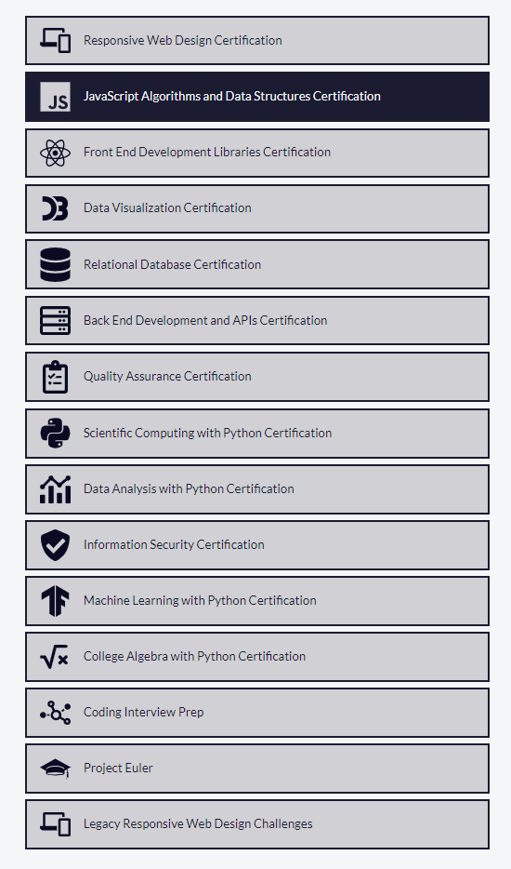

6. Hyperlinks – were used in footer.

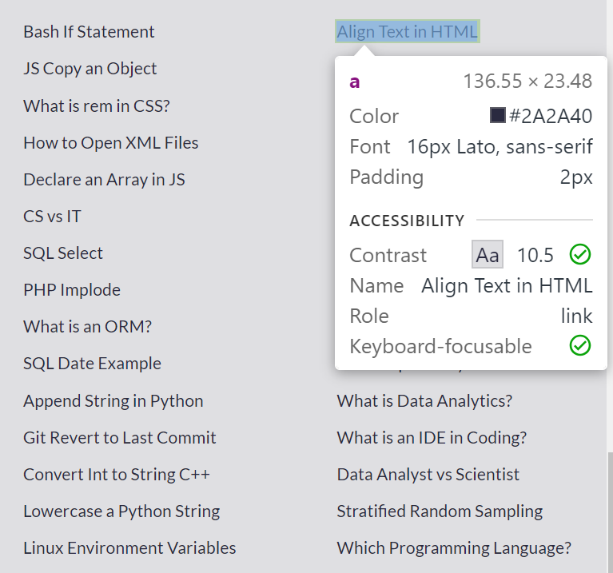

7. Images – used in SVG format



8. Forms -

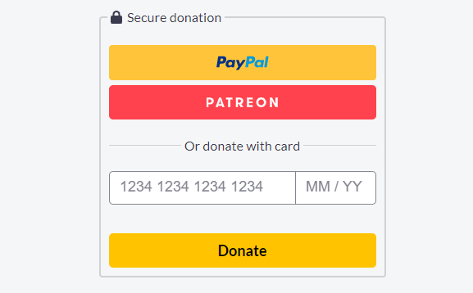

9. Input types – text, number.

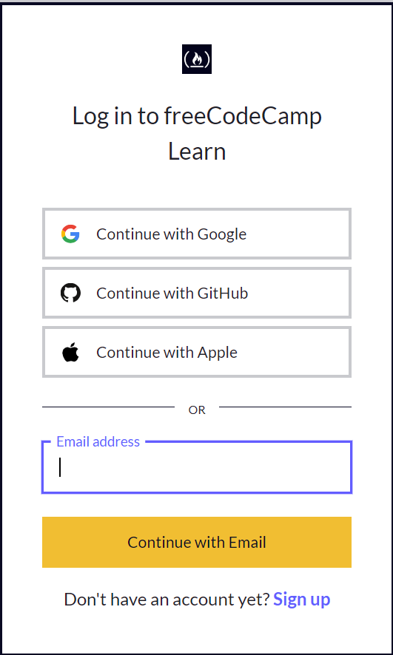

10. Attributes - href, style, src

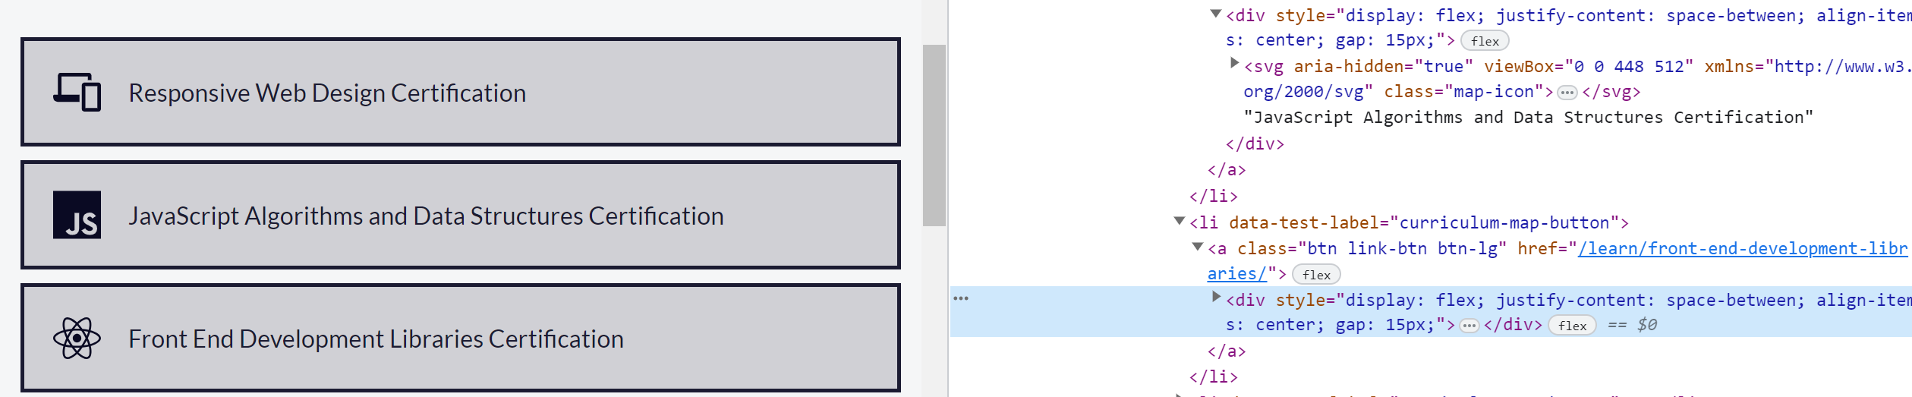

11. Formatting – ul, span, h1, p, li



12. Comments - There is no comments were used in this webpage.

13. HTML Entities – There is no entities used in this page

14

14. Validation -

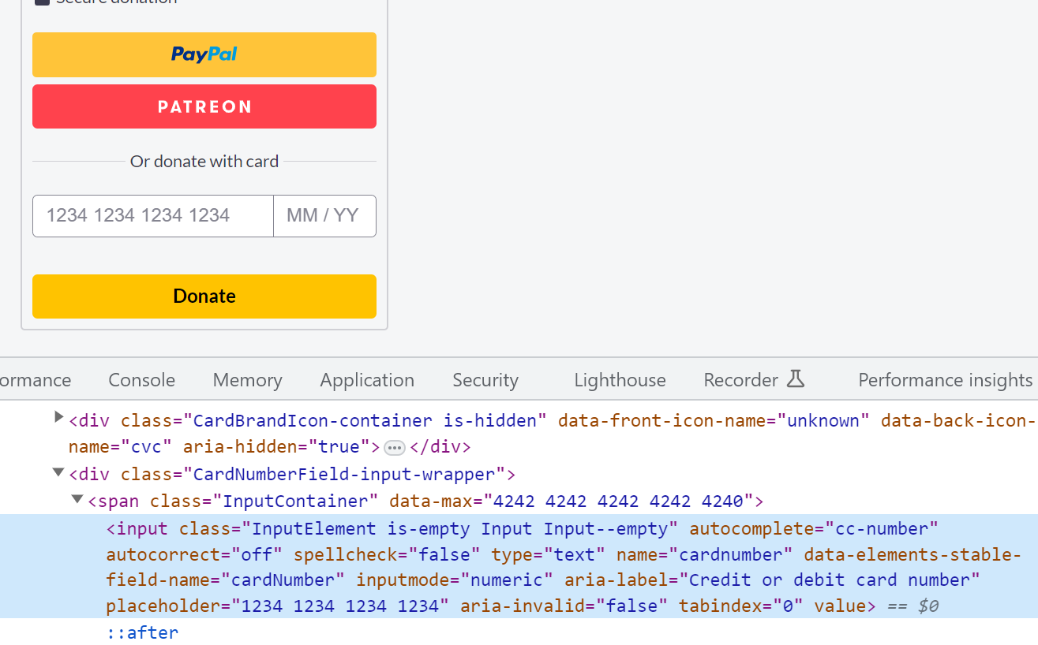

Escape chracters – No escape characters used in webpage

16. Nesting -

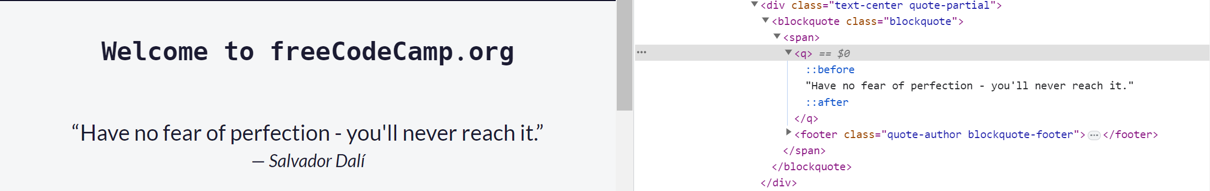

17. HTML API -

18. Inline and block level elements ;

